
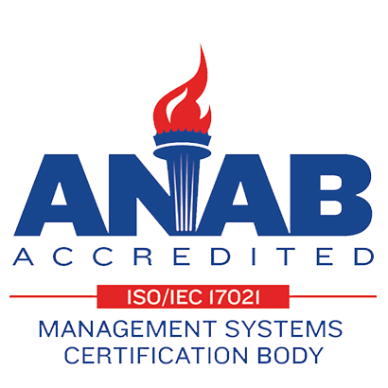

Contour Machine Ltd. Sheet Metal Fabrication Specialists
Announcement

Contour Machine Ltd. is proud to announce that we have now have a new AMADA EMK 3612 CNC Turret punch press fully operational to meet your requirements!

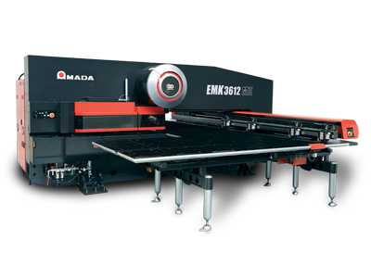
The 3612 Processes 10'x5' sheets without repositioning, the highest real-world hit rates and ram positioning accuracy. Precision ram motion control (speed, stroke length, hover height and hold time) Standard 58-station triple track, King turret.
High quality, press-brake-like forming operations up to ½" with programmable dwell at bottom of stroke for complete plastic deformation. A free standing PC-based network CNC control allows for flexible layout of your designs to help maximize material yield.
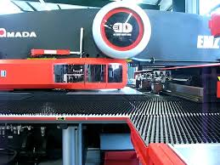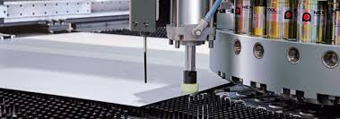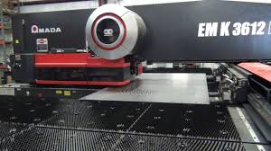

Progressive forms, flanges and embossments up to ½" eliminate secondary operations Brush table design provides scratch-free processing, eliminating secondary finishing.

Please contact us for more information or if you have any items you would like competitive quotations on.

Contact :

120 Toro Rd North York Ontario M3J 2A9 John Baxter- President jbaxter@contourmachine.com
Tel (416) 747-7997, Fax: (416) 747-8491 Marino Molella- Technical Sales Sales@contourmachine.com
Web: contourmachine.com

